ICS344 Secure Communication System - User Guide
Project: Cryptography in Action – Secure Messaging Application
Bucket: P01 (Python | AES-CBC PKCS#7 | Diffie-Hellman | Dictionary | Message injection | Session hijacking | Flooding messages | Desktop)
Team: ICS344 Project Team 41
Members: Muhammad Jaddoua – Husain Althagafi
Institution: King Fahd University of Petroleum & Minerals

Table of Contents
- Introduction
- Getting Started
- Using the Application

1. Introduction
Welcome to the Secure Communication System, a desktop application designed to demonstrate cryptographic principles including encryption, key exchange, and security attack simulations. This application provides an interactive environment for understanding how modern secure communication works.
Key Features:
- AES-256-CBC encryption with PKCS#7 padding
- Diffie-Hellman key exchange
- Two-client communication simulation
- Four different attack simulations
- Real-time security event logging

2. Getting Started

Launching the Application
Launch the pre-installed executables unzipping the correct release for your system
The application window will appear with the following components:
- Client A Text Area (left panel)
- Client B Text Area (right panel)
- Control Buttons for encryption and decryption
- Attack Simulation Controls at the bottom
- System Log Panel showing security events
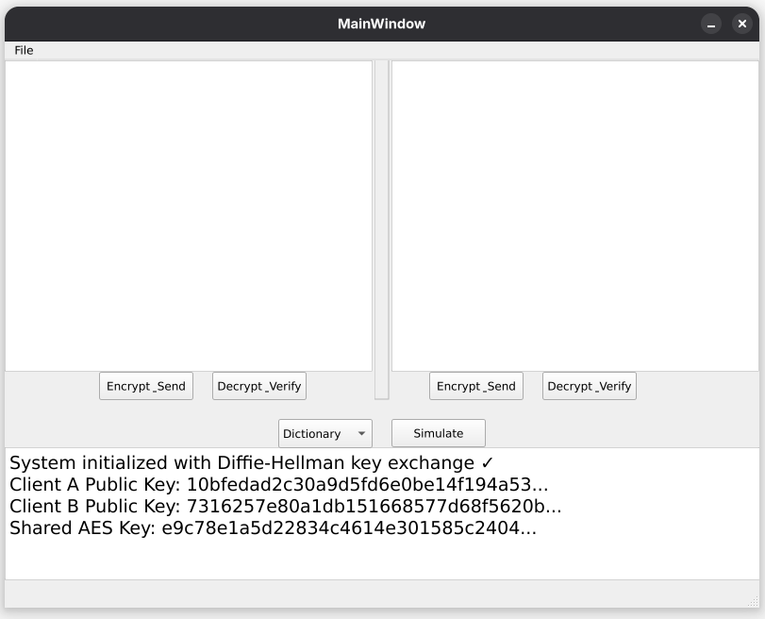Figure 1: Main application window with labeled components

3. Using the Application

Sending an Encrypted Message
Step 1: Type your message in the respective client you want to send from.
Step 2: Click the "Encrypt & Send" button under the respective client's panel.
Step 3: The encrypted message (Base64-encoded ciphertext) will appear in the other client’s text area.
Step 4: With the encrypted message visible in a client's window, click “Decrypt & Verify” button to Decrypt the message.
Step 5: Observe the output in the system logs.
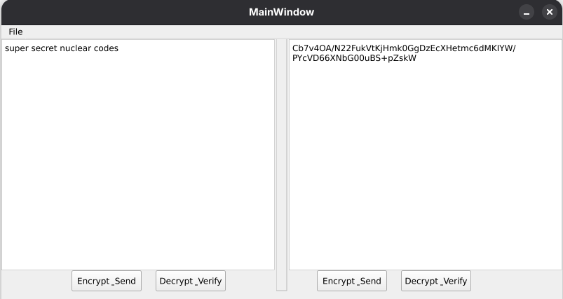

Attack Simulations
The application includes four security attack simulations as specified in the project requirements. These demonstrate common threats to cryptographic systems and how they are defended against.
Steps to Simulate:
- Select the requested attack from the attack type dropdown menu
- Click the "Simulate" button
- Watch the system log as it attempts the attack
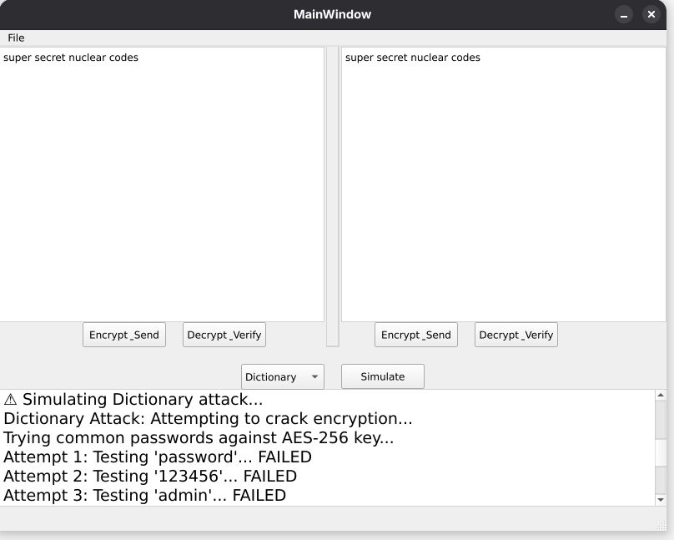Figure 3: Dictionary attack simulation in progress with failed attempts in logs

